**Automating the Department of Ecology Wetland Rating System for Washington State**

______________________________________________________________________________

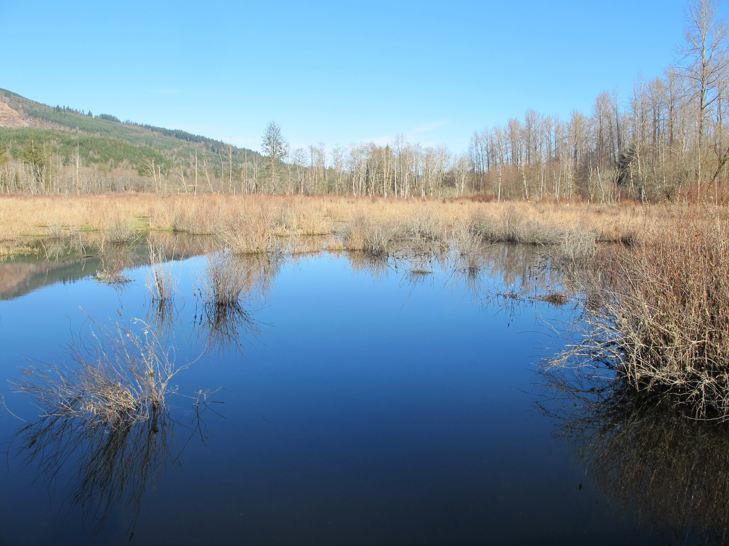

**Samantha Thompson,**

**Patrick Warner, and**

**Amy Dearborn**

**GEOG 565**

**May 2018**

**Abstract**

This project utilizes Python scripting to create a set of tools that automates map production used in assessment of wetlands required by Washington State’s Department of Ecology. The final product varies from the original proposed project because it does not include automated scripting regarding wetland ratings that are used in field work. However, the editing and geoprocessing of data that is then produced into a map remains. A user will be able to use the toolbox and select from various tools that are used to create informative maps about wetlands. Some of the tools include creating a study area, clipping, buffers, and quickly adding additional files to the map. The final output is the creation of a PDF with the option to create multiple PDFs via Data Driven pages.

**Background**

Wetlands are a key component of Washington's landscape and are abundantly found throughout the state. Wetland areas perform complex functions and provide various environmental services that make them valuable, both ecologically and economically. In Washington state, the Growth Management Act requires critical area evaluations to be performed for any potential development site across the state to determine impacts from development and assure ‘No Net Loss’ of ecosystem functions and values. The Washington State Department of Ecology has developed a rating system to use for evaluation of wetland condition. It is generally required that all biologists employ the wetland rating forms and place a copy of it in their Critical Area Assessment Reports.

Two different methodologies exist, one for western Washington and one for eastern Washington, with the Cascade Mountain range being the dividing line. The respective wetland rating methodologies separate wetlands into categories based on geomorphic position in the landscape, and are the basis for protective buffers, quantity of compensatory mitigation required to negate impacts of development and can help determine different permitted uses of the critical area, as required by jurisdictional land use codes.

The Department of Ecology Wetland Rating forms for Washington State are required documentation for development projects in and within 200 feet of potential wetland areas. The rating forms require standard map submission with the forms to reference how the questions in the form are answered. However, these wetland rating forms are often daunting, tedious, and repetitive. Production of these base maps can be automated to provide consistency, accuracy, and save time in the preparation of required documentation. The Appendix has further information on tools used for map production. Links to the requirements and forms can be found here: <https://ecology.wa.gov/Water-Shorelines/Wetlands/Tools-resources/Rating-systems> and <https://fortress.wa.gov/ecy/publications/parts/1406029part1.pdf>

**Project Methods and Design**

The original workflow for this project is shown below in Figure 1. The user could input their own data into the script where different geoprocessing could take place, including a mechanism for wetland ratings with the final output being a map or multiple maps in PDF form.

Basin Raster

Landcover Raster

Vector Input

1 Km buffer

Intersect

Raster to Polygon

Field Calculator

Assign Watershed ratings (update attribute table)

Data Driven Map Production

Topography

Aerial Imagery

Final Output

Flow

Basin Calc

Categorize Wetland Type

SQL query for wetlands

Score Wetlands

DEM Raster

Slope calc

*Figure 1, Original Intended Workflow*

However, the final result is modified from the original workflow. The wetland ratings portion of the workflow was not incorporated at this time due to time restrictions and complexity of scripting the wetland ratings parameters. Instead the user has a toolbox derived from Python scripts where multiple tools can be used as needed, independently of one another. The toolbox still favors common operations that would be used in wetland ratings processing, but as the toolbox is now, it could be used more broadly. The user can simply input their own data and alter desired parameters. The final result is still a map that is saved as a PDF with the option to use Data Driven pages to create multiple maps.

Assumptions

* The user has their own data available
* Georeferencing imagery must be done manually
* Map elements must already exist on the map
* MXD files must already exist
* Data Driven Pages must be turned on to utilize DataDrivenPages tool

The Toolbox

**Clip and Buffer Layers:** The first tool allows the user to begin managing the data for analysis. There is a total of 13 inputs for workspaces, multiple shapefiles, and/or rasters. It geoprocesses the intended water layers with a one-kilometer buffer, clipping all the user-inputted data with a required clip feature input. The final result is a final buffer that uses one input, or a merged buffer from two inputs, and multiple clipped layers in the tool geodatabase. Most of the inputted data is optional so the user can geoprocess data easier.

*Figure 2. Clip/Buffer Tool*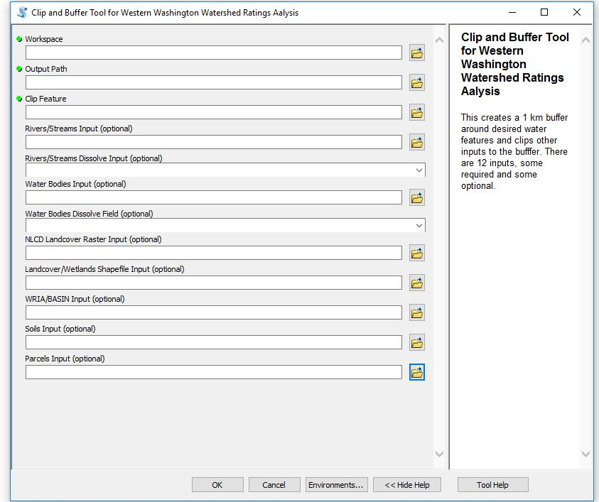

**Import Layers:** This tool allows the user to select an existing map document and select any layer they would like to add to that map. This helps to speed up map production because it gives the user freedom to put layers in any map document quickly, it is especially useful if many map documents are being used. Also, if a legend exists on the map, each layer will be represented on the legend as it is added to the map.

**Intersect Tool:** Similar to the intersect tool provided by ArcGIS but is readily available in the toolbox and script can quickly be edited to customize data types. The inputs for the clip can be pulled from any existing files.

**Study Area Tool:** Allows the user to create a new polygon from coordinates of four points. This allows for exactness when defining a study area and multiple study areas could be created.

*Figure 3. Study Area Tool*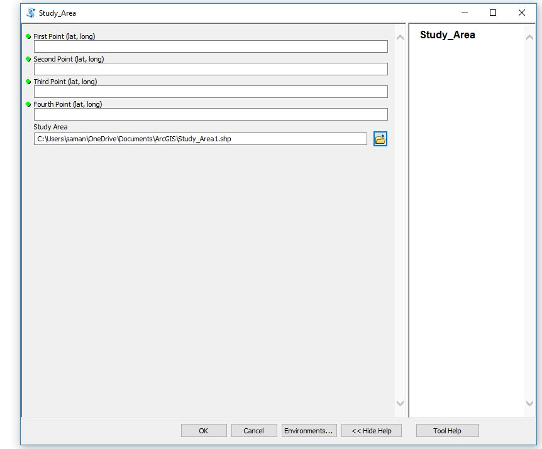

**Map Production Tool:** This tool allows the user to update the title, author, and summary for a selected map document. Imagery files can quickly be added. And the user can quickly save this piece as a PDF. All inputs are optional in this tool so the user can just update one parameter at a time and can create a PDF when ready.

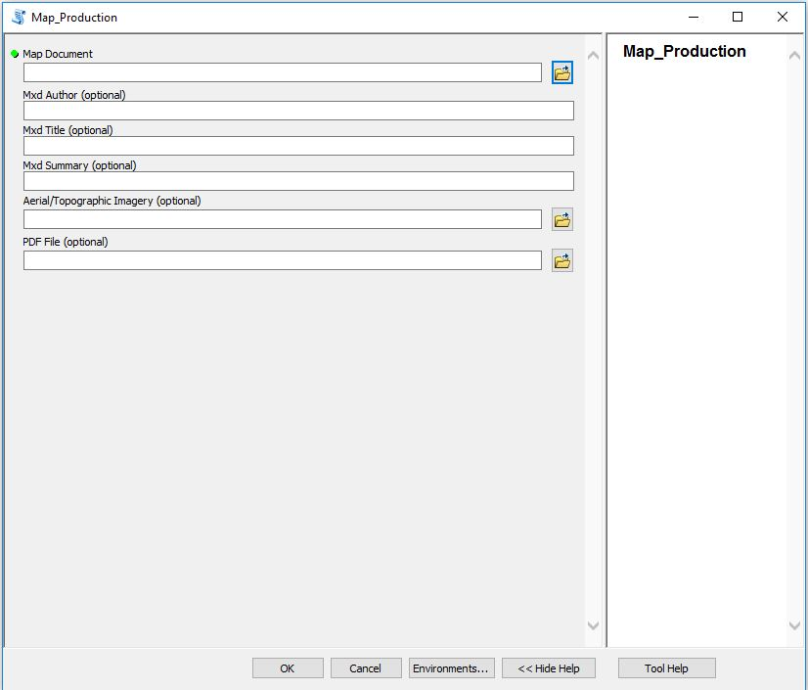

*Figure 4. Map Production Tool*

**Data Driven Pages Tool:** This tool allows the user to export an .mxd file that has Data Driven pages turned on. The user can select a page, a range of pages, or the whole document and it will combine all of the maps together into one PDF file

**Merge PDF Tool:** This tool allows the user to select any 2 PDF files and merge them together. This is useful for map production, especially if the user does not use Data Driven pages and wishes to combine separate PDF documents (likely maps) quickly.

Deliverables

The toolbox (with associated scripts), this document, and the test files have been put together in a zip file. The toolbox will show each individual tool and the test files have been moved into a geodatabase, each in their respective folders. The document also has its own folder.

**Results**

By utilizing a toolbox, each tool works independently of each other making testing of functionality easier. It also allows for the toolbox to be expanded or simplified easier. From the user’s perspective, once the user knows what data they need to add, they barely have to do much in the way of data processing. They can quickly perform clip, buffering, intersect, define a study area, add layers as need, and produce a basic map(s). This is useful for a user who needs to process data quickly and output maps quickly without much altering or customizations of map elements. The current toolbox functions, but if this toolbox were to be used in a real-world setting, more tools or functionality might need to be added, like a georeferencing script for example. Additionally since the scripting necessary for wetland ratings was omitted for the scope of this project, adding that portion back in would make our tool more specific and more desirable to be used.

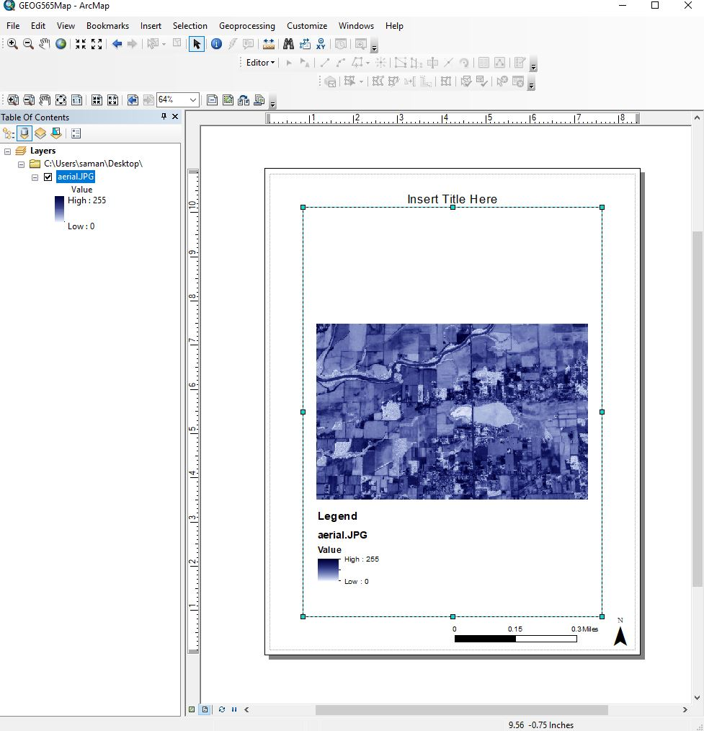

*Figure 5. Map Production Output with Imagery File*

**Conclusions**

The created script for automation sets a workflow for multiple inputs with different geoprocessing tools. The script created supports the problem statement by determining, yes, there is automation that can prepare base maps for the average ArcMap user of the wetland rating system. Maps required by the form are important for showing the work for answering the rating form questions. The original proposal was intended in to include a workflow meant to cover the entire wetlands rating process from data creation to the final map presentation. However, simplification of the process was crucial for the time and intent of the class structure, which was to display the skills obtained through the class. The result of this project is a python script for the workflow to cover all of the steps for basic map production while providing feedback messages that inform the user what step the tool is taking to the final output.

The data collected for testing originated from readily available and local government sources. There are likely other sources of data from different jurisdictions that may need processing to fit within this script. Ideally this map set and toolbox would be useful in painting a digital picture of the wetland being studied, and the surrounding land use no matter where applied.

The Washington State Department of Ecology has grant money set aside for the creation of GIS system to support for the rating form. They are in the fledgling stage of scoping and identifying a stakeholder group. When their project is farther along, this script for automation may come in useful for incorporation to the government system.

**Recommendations**

The data used to test this script may be limited by the complexity of the parameters available at the test location. It would be useful to test a broad audience interested in automation of map products to determine the array of needs from the wetland community. At this early stage, this automation may not be useful for creating a full spectrum map product for responding to questions on the wetland rating form. Resolving automation needs takes refined scoping and design of the data attributes. More information is needed for the specific types of data to integrate into the script. Identifying the issues through a refined scoping process would help guide the type of automation improvements possible. Research is also needed into the types of automated wetland mapping projects already on the ground to help simplify and synthesize data.

If others were to undertake this study, identifying the interactions of the data for use in the script product would reducing it to a tangible dataset, which is key to making a usable GIS work product. One would do well to keep a tight focus on the stages of scoping, design, and implementation, and revisit them often. It is easy to be distracted by available data. However, solving the problem of map automation and consistency may require a large toolbox of approaches to use with the diverse nature of regional ecologies and relational datasets.

The future steps toward developing an automated system for the wetland ratings may include:

* Design and implementation of a revised script that may better synthesize and collaborate GIS data and wetland field data.
* Reaching out to jurisdictions for more insight on potential needs, goals, and limitations for data resources and coding needs.
* Research further the types of data that is problematic and determine the potential methods of scripting for simplification and integration into a schema.
* Prepare a script that dovetails existing projects with potential future project locations. Spatial integration. Have them build upon each other for greater effect and refinement of a holistic automation system.

**Bibliography, References and Online Resources**

DNR (Washington State Department of Natural Resources), 2018. Wetlands of High Conservation Value Map Viewer. Available from: <http://www.dnr.wa.gov/NHPwetlandviewer>

Ecology, 2014. *Wetland Washington Wetland Rating Form: 2014 Update.* Ecology Publication #14-0600303. January 2015.

Ecology, 2016. Washington State Water Quality Atlas. Available online from: <http://www.ecy.wa.gov/programs/wq/303d/index.html>

Hruby, T., 2014. *Washington State Wetland Rating System for Western Washington: 2014 Update*. Publication #14-06-018. June 1988.

King County, Washington. King County GIS data portal.<http://www5.kingcounty.gov/gisdataportal/>

King County, Washington. Science Seminars. <http://green2.kingcounty.gov/scienceseminars/>

USDA, 2018. *National Hydric Soil List*. USDA Soil Conservation Service. Available online from: <https://www.nrcs.usda.gov/wps/portal/nrcs/main/soils/use/hydric>

USFWS (U.S. Fish and Wildlife Service), 2018. National Wetlands Inventory online mapper. Available online from: <https://www.fws.gov/wetland/data/Mapper.html>

WDFW (Washington Department of Fish and Wildlife), 2018. WDFW PHS online. Available online from: <http://apps.wdfw.wa.gov/phsontheweb/>

Zandbergen, Paul A. Python, Scripting for ArcGIS. EsriPress, 2013.

**Appendix**

Parameters and Tools Needed to Complete the Wetland Ratings Forms

The Wetland Rating Forms require a set of maps with similar, but basic parameters. The parameters within the ArcMap toolbox are listed below and tools in Table 1:

1. 1 km buffer around water features is required for evaluation of land uses.
2. Slope is a determining factor in which Rating Form is used, defining the contributing basin, the downstream basin, and important for identifying inlet and outlets for hydrology.
3. Land Cover types are classified into land use intensity.
4. Soil Type is evaluated by the NRCS Soil Classification database.
5. Field calculator for scores on the statements.

*Table 1 - List of python tools*

|  |
| --- |
| **Python Tools** |
| Field calculator |
| Cursor (update, insert, search) |
| Arcpy Geoprocessing (intersect, buffering, etc.) |
| Data driven maps and mapping module |
| Error testing with try and exceptions |
| Raster geoprocessing (slope, flow basin) |
| SQL queries |

The most common form used in Western Washington is for Depressional Wetlands. It is the most common wetland type. The general parameters for the Depressional Wetland forms are described in Table 2.

*Table 2 - List of required parameters for map production*

|  |
| --- |
| **General Parameters for Map Features for Depressional Wetlands** |
| Cowardin plant classification (from NWI) |
| Hydroperiods (from USGS and NWI) |
| Location of inlet and outlet (topo and WRI) |
| Boundary of area within 150 ft of the wetland |
| Map of the contributing basin (topo and WRI) |
| 1 km Polygon: Area that extends 1 km from entire wetland edge - including polygons for accessible habitat and undisturbed habitat (Land use classification) |
| 303(d) listed waters in 1 km radius (EPA) |
| TMDLs for WRIA in which unit is found (EPA and Ecology) |

*Table 3 - Resources and weblinks for data acquisition.*

|  |  |
| --- | --- |
| **Resource** | **Link** |
| WA Ecology Watershed Map | <https://fortress.wa.gov/ecy/coastalatlas/wc/landingpage.html> and <https://ecology.wa.gov/Research-Data/Data-resources/Geographic-Information-Systems-GIS/Maps> |
| USGS Water Resource Inventory | <https://water.usgs.gov/maps.html> |
| USGS Soil Survey | <https://websoilsurvey.sc.egov.usda.gov/app/HomePage.htm> |
| National Wetland Inventory | <https://www.fws.gov/wetlands/Data/Mapper.html> |
| EPA 303d Inventory | <https://www.epa.gov/tmdl> |
| National Land Cover Map | <https://nationalmap.gov/landcover.html> |
| USGS Maps - Topography | <https://www.usgs.gov/products/maps/topo-maps> |